# Accessing Your Model's Data from a Controller

In this section, you'll create a new MoviesController class and write code that retrieves the movie data and displays it in the browser using a view template.

**Build the application** before going on to the next step. If you don't build the application, you'll get an error adding a controller.

In Solution Explorer, right-click the Controllers folder and then click **Add**, then **Controller**.

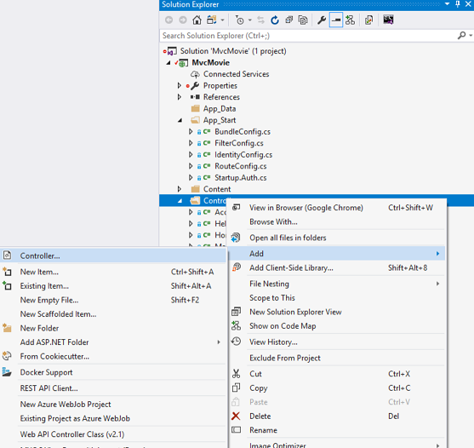

In the **Add Scaffold** dialog box, click **MVC 5 Controller with views, using Entity Framework**, and then click **Add**.

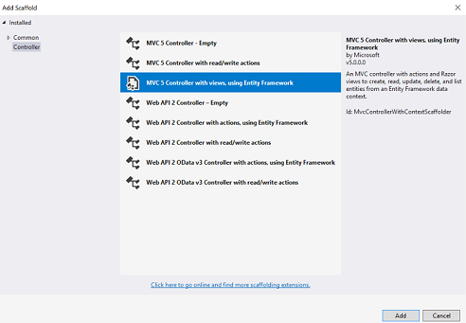

* Select **Movie (MvcMovie.Models)** for the Model class.
* Select **MovieDBContext (MvcMovie.Models)** for the Data context class.
* For the Controller name enter **MoviesController**.

The image below shows the completed dialog.

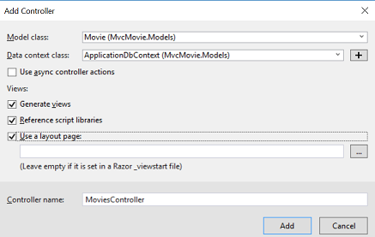

Click **Add**. (If you get an error, you probably didn't build the application before starting adding the controller.) Visual Studio creates the following files and folders:

* A MoviesController.cs file in the Controllers folder.
* A Views\Movies folder.
* Create.cshtml, Delete.cshtml, Details.cshtml, Edit.cshtml, and Index.cshtml in the new Views\Movies folder.

Visual Studio automatically created the [CRUD](http://en.wikipedia.org/wiki/Create,_read,_update_and_delete) (create, read, update, and delete) action methods and views for you (the automatic creation of CRUD action methods and views is known as scaffolding). You now have a fully functional web application that lets you create, list, edit, and delete movie entries.

Run the application and click on the **MVC Movie** link (or browse to the Movies controller by appending /Movies to the URL in the address bar of your browser). Because the application is relying on the default routing (defined in the App_Start\RouteConfig.cs file), the browser request http://localhost:xxxxx/Movies is routed to the default Index action method of the Movies controller. In other words, the browser request http://localhost:xxxxx/Movies is effectively the same as the browser request http://localhost:xxxxx/Movies/Index. The result is an empty list of movies, because you haven't added any yet.

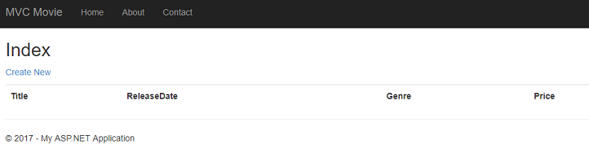

### Creating a Movie

Select the **Create New** link. Enter some details about a movie and then click the **Create** button.

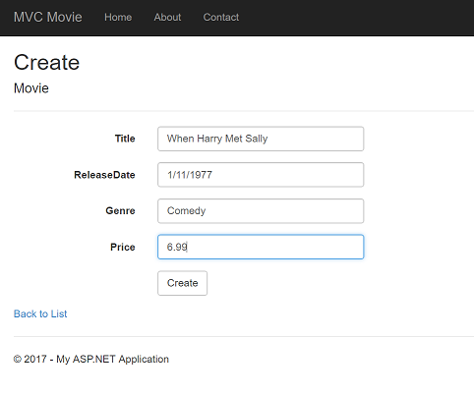

Note

You may not be able to enter decimal points or commas in the Price field. To support jQuery validation for non-English locales that use a comma (",") for a decimal point, and non US-English date formats, you must include globalize.js and your specific cultures/globalize.cultures.js file(from <https://github.com/jquery/globalize> ) and JavaScript to use Globalize.parseFloat. I'll show how to do this in the next tutorial. For now, just enter whole numbers like 10.

Clicking the **Create** button causes the form to be posted to the server, where the movie information is saved in the database. You're then redirected to the /Movies URL, where you can see the newly created movie in the listing.

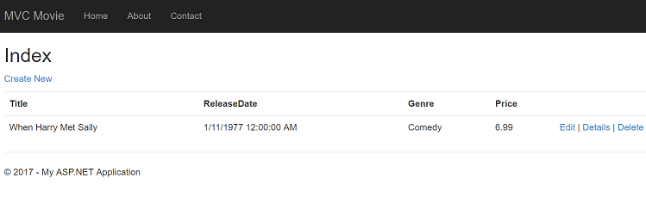

Create a couple more movie entries. Try the **Edit**, **Details**, and **Delete** links, which are all functional.

## Examining the Generated Code

Open the Controllers\MoviesController.cs file and examine the generated Index method. A portion of the movie controller with the Index method is shown below.

C#

public class MoviesController : Controller

{

private MovieDBContext db = new MovieDBContext();

// GET: /Movies/

public ActionResult Index()

{

return View(db.Movies.ToList());

}

A request to the Movies controller returns all the entries in the Movies table and then passes the results to the Index view. The following line from the MoviesController class instantiates a movie database context, as described previously. You can use the movie database context to query, edit, and delete movies.

C#

private MovieDBContext db = new MovieDBContext();

## Strongly Typed Models and the @model Keyword

Earlier in this tutorial, you saw how a controller can pass data or objects to a view template using the ViewBag object. The ViewBag is a dynamic object that provides a convenient late-bound way to pass information to a view.

MVC also provides the ability to pass strongly typed objects to a view template. This strongly typed approach enables better compile-time checking of your code and richer [IntelliSense](https://msdn.microsoft.com/en-us/library/hcw1s69b(v=vs.120).aspx) in the Visual Studio editor. The scaffolding mechanism in Visual Studio used this approach (that is, passing a strongly typed model) with the MoviesController class and view templates when it created the methods and views.

In the Controllers\MoviesController.cs file examine the generated Details method. The Details method is shown below.

C#

public ActionResult Details(int? id)

{

if (id == null)

{

return new HttpStatusCodeResult(HttpStatusCode.BadRequest);

}

Movie movie = db.Movies.Find(id);

if (movie == null)

{

return HttpNotFound();

}

return View(movie);

}

The id parameter is generally passed as route data, for example http://localhost:1234/movies/details/1 will set the controller to the movie controller, the action to details and the id to 1. You could also pass in the id with a query string as follows:

http://localhost:1234/movies/details?id=1

If a Movie is found, an instance of the Movie model is passed to the Details view:

C#

return View(movie);

Examine the contents of the Views\Movies\Details.cshtml file:

CSHTML

@model MvcMovie.Models.Movie

@{

ViewBag.Title = "Details";

}

<h2>Details</h2>

<div>

<h4>Movie</h4>

<hr />

<dl class="dl-horizontal">

<dt>

@Html.DisplayNameFor(model => model.Title)

</dt>

@*Markup omitted for clarity.*@

</dl>

</div>

<p>

@Html.ActionLink("Edit", "Edit", new { id = Model.ID }) |

@Html.ActionLink("Back to List", "Index")

</p>

By including a @model statement at the top of the view template file, you can specify the type of object that the view expects. When you created the movie controller, Visual Studio automatically included the following @model statement at the top of the Details.cshtml file:

CSHTML

@model MvcMovie.Models.Movie

This @model directive allows you to access the movie that the controller passed to the view by using a Model object that's strongly typed. For example, in the Details.cshtml template, the code passes each movie field to the DisplayNameFor and [DisplayFor](https://msdn.microsoft.com/en-us/library/system.web.mvc.html.displayextensions.displayfor(VS.98).aspx) HTML Helpers with the strongly typed Model object. The Create and Edit methods and view templates also pass a movie model object.

Examine the Index.cshtml view template and the Index method in the MoviesController.cs file. Notice how the code creates a [List](https://msdn.microsoft.com/en-us/library/6sh2ey19.aspx) object when it calls the View helper method in the Index action method. The code then passes this Movies list from the Index action method to the view:

C#

public ActionResult Index()

{

    return View(db.Movies.ToList());

}

When you created the movie controller, Visual Studio automatically included the following @model statement at the top of the Index.cshtml file:

CSHTML

@model IEnumerable<MvcMovie.Models.Movie>

This @model directive allows you to access the list of movies that the controller passed to the view by using a Model object that's strongly typed. For example, in the Index.cshtml template, the code loops through the movies by doing a foreach statement over the strongly typed Model object:

CSHTML

@foreach (var item in Model) {

    <tr>

        <td>

            @Html.DisplayFor(modelItem => item.Title)

        </td>

        <td>

            @Html.DisplayFor(modelItem => item.ReleaseDate)

        </td>

        <td>

            @Html.DisplayFor(modelItem => item.Genre)

        </td>

        <td>

            @Html.DisplayFor(modelItem => item.Price)

        </td>

         <th>

            @Html.DisplayFor(modelItem => item.Rating)

        </th>

        <td>

            @Html.ActionLink("Edit", "Edit", new { id=item.ID }) |

            @Html.ActionLink("Details", "Details", new { id=item.ID })  |

            @Html.ActionLink("Delete", "Delete", new { id=item.ID })

        </td>

    </tr>

}

Because the Model object is strongly typed (as an IEnumerable<Movie> object), each item object in the loop is typed as Movie. Among other benefits, this means that you get compile-time checking of the code and full IntelliSense support in the code editor:

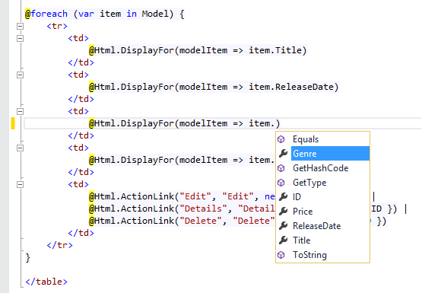

## Working with SQL Server LocalDB

Entity Framework Code First detected that the database connection string that was provided pointed to a Movies database that didn't exist yet, so Code First created the database automatically. You can verify that it's been created by looking in the App_Data folder. If you don't see the Movies.mdf file, click the **Show All Files** button in the **Solution Explorer** toolbar, click the **Refresh** button, and then expand the App_Data folder.

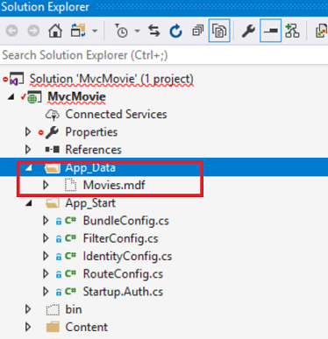

Double-click Movies.mdf to open **SERVER EXPLORER**, then expand the **Tables** folder to see the Movies table. Note the key icon next to ID. By default, EF will make a property named ID the primary key. For more information on EF and MVC, see Tom Dykstra's excellent tutorial on [MVC and EF](https://docs.microsoft.com/en-us/aspnet/mvc/overview/getting-started/getting-started-with-ef-using-mvc/creating-an-entity-framework-data-model-for-an-asp-net-mvc-application).

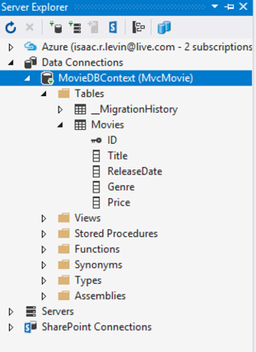

Right-click the Movies table and select **Show Table Data** to see the data you created.

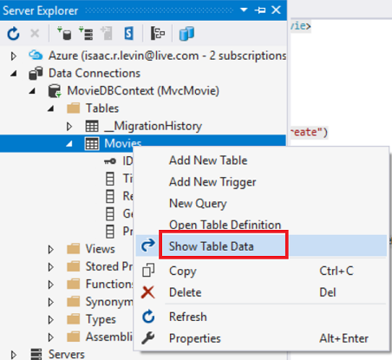

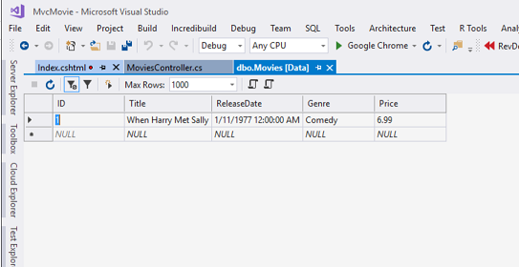

Right-click the Movies table and select **Open Table Definition** to see the table structure that Entity Framework Code First created for you.

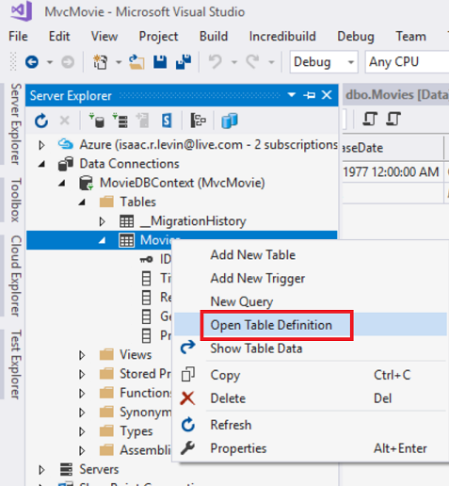

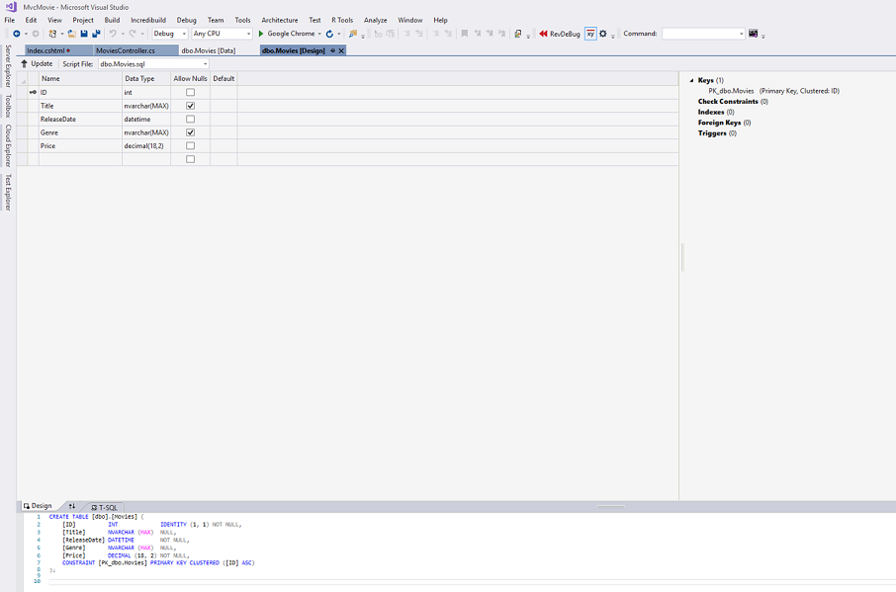

Notice how the schema of the Movies table maps to the Movie class you created earlier. Entity Framework Code First automatically created this schema for you based on your Movie class.

When you're finished, close the connection by right clicking MovieDBContext and selecting **Close Connection**. (If you don't close the connection, you might get an error the next time you run the project).

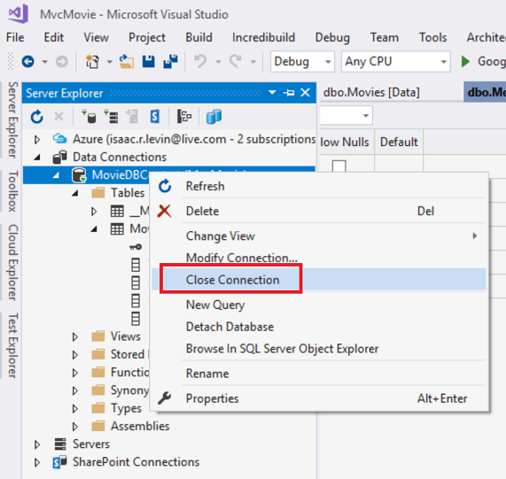

You now have a database and pages to display, edit, update and delete data. In the next tutorial, we'll examine the rest of the scaffolded code and add a SearchIndex method and a SearchIndex view that lets you search for movies in this database.